The Creation
Genesis 1: 1-31 – 2: 4
This pack includes activities based on “The Creation”, sourced from the internet, for children 5-11.

Activities include:
- Bible verses for journaling
- Wordsearches
- Crosswords
- Code words
- Dot to dots
- Colour by numbers
- Colouring Sheets
- Spot the difference
- Jigsaws

The Story of Creation
Read the bible verses and then draw pictures around the bible verses of everything mentioned in the “Story of Creation”. Make it as colourful as possible.
¹
¹In the beginning, when God created the universe, ²the earth was formless and desolate. The raging ocean that covered everything was engulfed in total darkness, and the Spirit of God was moving over the water. ³Then God commanded, “Let there be light” — and light appeared. ⁴God was pleased with what he saw. Then he separated the light from the darkness, ⁵and he named the light “Day” and the darkness “Night”. Evening passed and morning came — that was the first day.
⁶⁻⁷Then God commanded, “Let there be a dome to divide the water and to keep it in two separate places” — and it was done. So God made a dome, and it separated the water under it from the water above it. ⁸He named the dome “Sky”. Evening passed and morning came — that was the second day.
⁹Then God commanded, “Let the water below the sky come together in one place, so that the land will appear” — and it was done. ¹⁰He named the land “Earth”, and the water which had come together he named “Sea”. And God was pleased with what he saw. ¹¹Then he commanded, “Let the earth produce all kinds of plants, those that bear grain and those that bear fruit” — and it was done. ¹²So the earth produced all kinds of plants, and God was pleased with what he saw. ¹³Evening passed and morning came — that was the third day.
¹⁴Then God commanded, “Let lights appear in the sky to separate day from night and to show the time when days, years, and religious festivals begin; ¹⁵they will shine in the sky to give light to the earth” — and it was done. ¹⁶So God made the two larger lights, the sun to rule over the day and the moon to rule over the night; he also made the stars. ¹⁷He placed the lights in the sky to shine on the earth, ¹⁸to rule over the day and the night, and to separate light from darkness. And God was pleased with what he saw. ¹⁹Evening passed and morning came — that was the fourth day.
https://www.biblesociety.org.uk/explore-the-bible/read/eng/GNB/Gen/1/
²⁰Then God commanded, “Let the water be filled with many kinds of living beings, and let the air be filled with birds.” ²¹So God created the great sea monsters, all kinds of creatures that live in the water, and all kinds of birds. And God was pleased with what he saw. ²²He blessed them all and told the creatures that live in the water to reproduce, and to fill the sea, and he told the birds to increase in number. ²³Evening passed and morning came — that was the fifth day.
²⁴Then God commanded, “Let the earth produce all kinds of animal life: domestic and wild, large and small” — and it was done. ²⁵So God made them all, and he was pleased with what he saw.
²⁶Then God said, “And now we will make human beings; they will be like us and resemble us. They will have power over the fish, the birds, and all animals, domestic and wild, large and small.” ²⁷So God created human beings, making them to be like himself. He created them male and female, ²⁸blessed them, and said, “Have many children, so that your descendants will live all over the earth and bring it under their control. I am putting you in charge of the fish, the birds, and all the wild animals. ²⁹I have provided all kinds of grain and all kinds of fruit for you to eat; ³⁰but for all the wild animals and for all the birds I have provided grass and leafy plants for food” — and it was done. ³¹God looked at everything he had made, and he was very pleased. Evening passed and morning came — that was the sixth day.
²
¹And so the whole universe was completed. ²By the seventh day God finished what he had been doing and stopped working. ³He blessed the seventh day and set it apart as a special day, because by that day he had completed his creation and stopped working. ⁴And that is how the universe was created.
https://www.biblesociety.org.uk/explore-the-bible/read/eng/GNB/Gen/1/
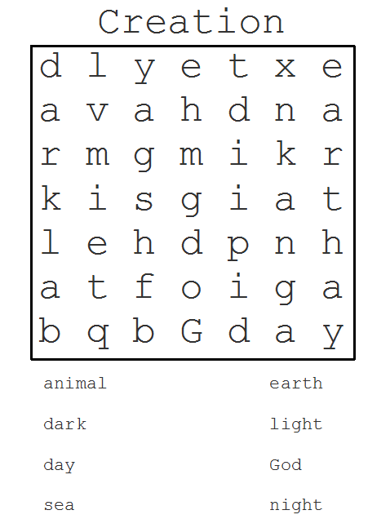
https://www.pinterest.co.uk/pin/487936940855378032/?nic_v1=1aDl65Ijb6%2FDNJ5O89Hp3AY9cnXoXdWirrNOsYBw91DKQQRKZYBvWE9WKPtspv%2BADf
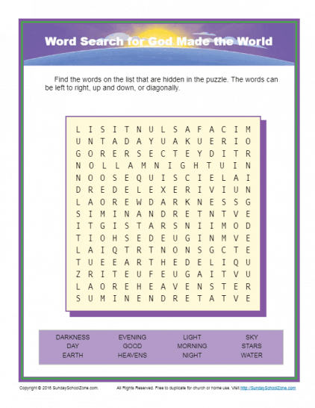
https://sundayschoolzone.com/activity/god-made-the-world-word-search/
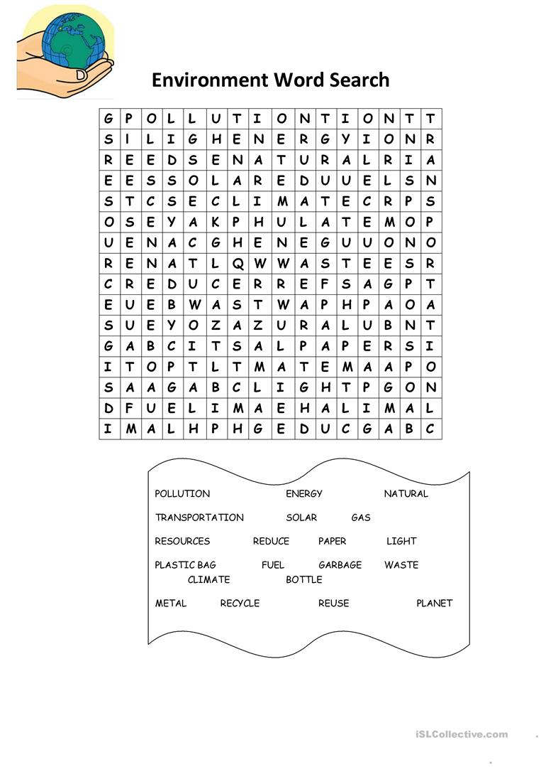
https://en.islcollective.com/english-esl-worksheets/vocabulary/environment/environment-wordsearch/75465
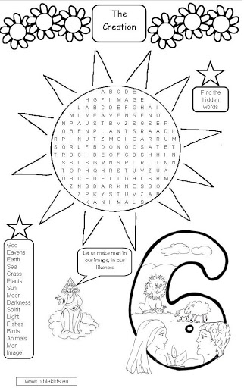
http://www.biblekids.eu/old_testament/creation/creation_html/creation_bible_word_search_1.html

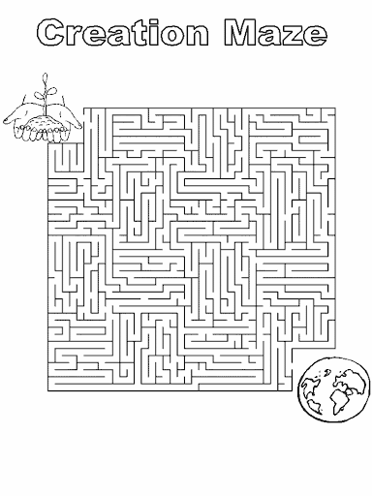
https://www.pinterest.co.uk/pin/354306695656792909/?nic_v1=1alQEB%2F1mO60oAm2zS1y3YqMsrGvREZIPU13B2TjPcE99wUjJPZOKHIc%2BdnoWNzB9U
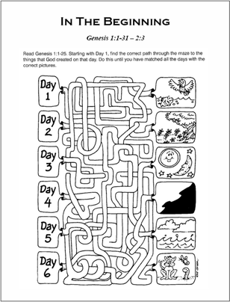
https://www.pinterest.co.uk/pin/410672059741453641/?nic_v1=1aPgu7JS2l0o5INeeVvzYwt1pz11FbFyszGuT364GmtA7OggMuVYRO4hfub7JXDoI5
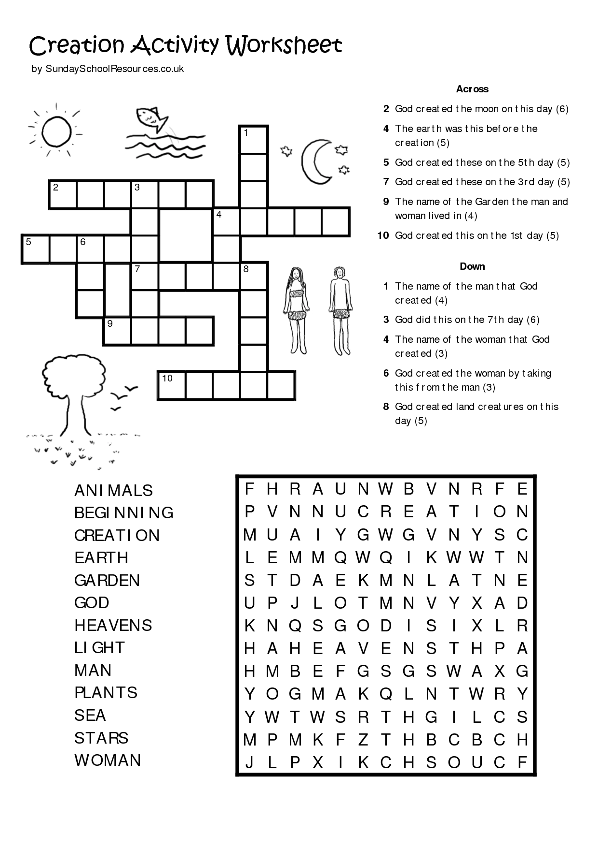
https://www.pinterest.co.uk/pin/411586853447569402/?nic_v1=1aFbpJYRfc%2FtOXw4nsURHrIgGWZATQzXu%2BGMCNHHuWv1pPr29s6h3atja1j0nI%2Bka%2B
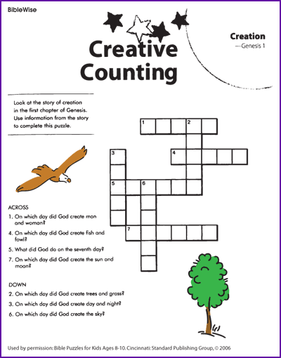
https://www.pinterest.co.uk/pin/287386019946864481/?nic_v1=1amM4kDowFeoBpr0sgBZ2sHNArNq6C1rhQZfG3fCsUl73eYdLMFocNUg0R%2B03WVnmk
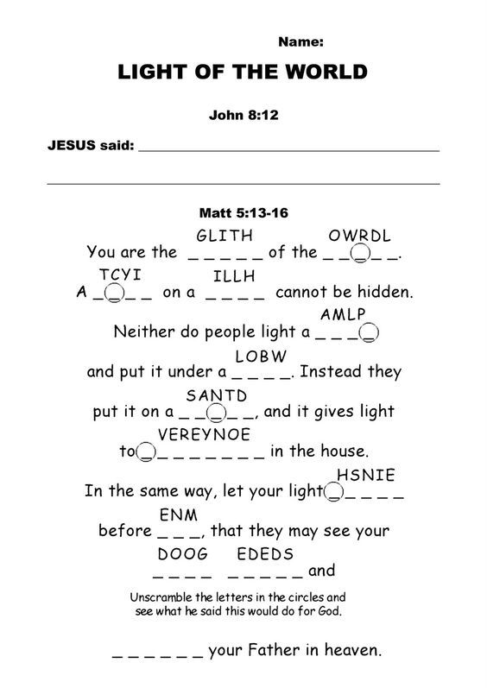
https://www.pinterest.co.uk/pin/470626229800960508/?nic_v1=1azFJHWVyEQlKQ%2B9JbzDEWyLdVTDO%2Fyae2K6MupN0s5dJlOm82w3Jv2BYiqc%2FT%2BmCm
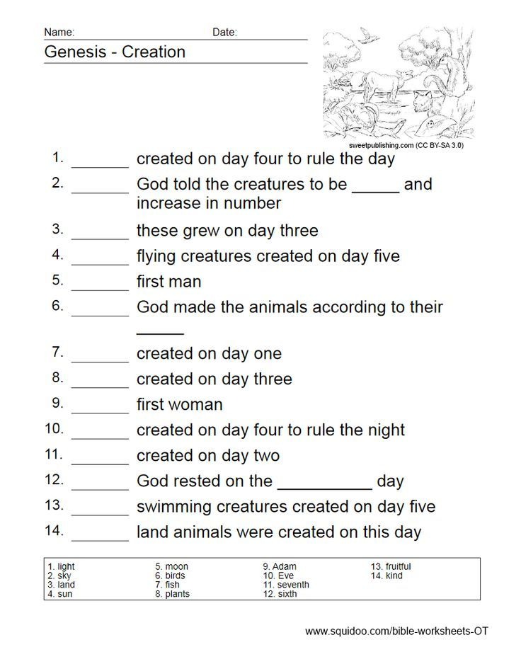
https://www.pinterest.co.uk/pin/521995413050788291/?nic_v1=1acEB6dc75ocofcjMx9s%2BiaUEM4E4TM0%2FUmy00bV%2F%2FHX9eWnBAKlJzk8UjrAZxTCRf
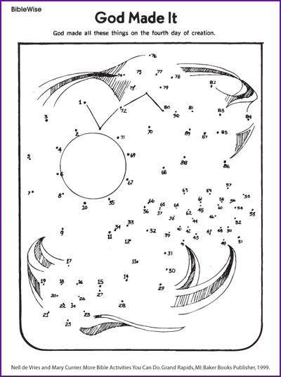
https://www.biblewise.com/kids/fun/god-made-it.php
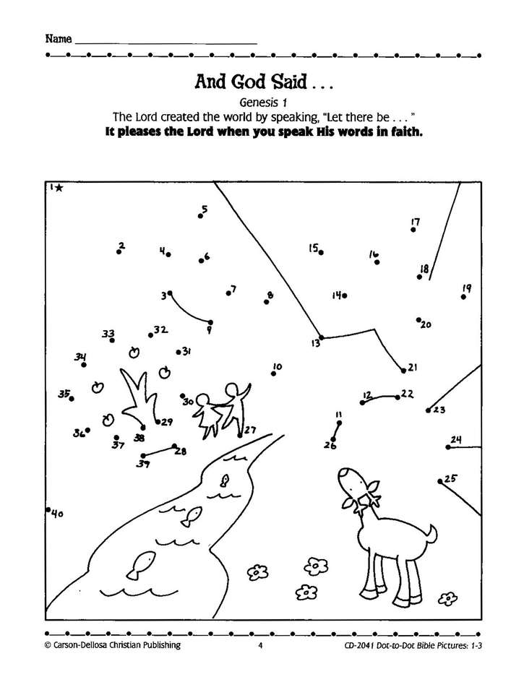
https://www.christianbook.com/dot-to-bible-pictures-gr-3/linda-standke/9780887242205/pd/242200

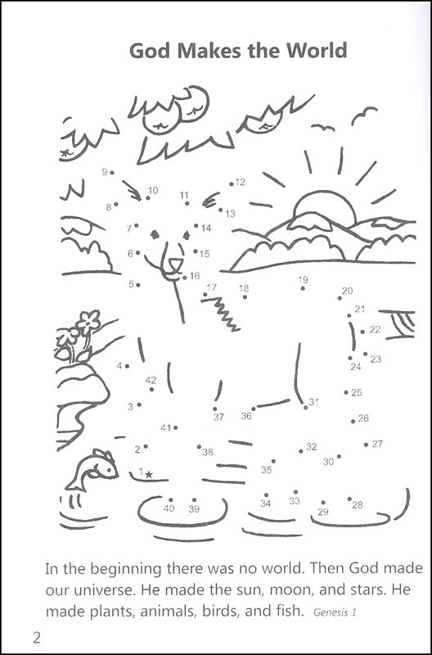
https://www.clipart.email/download/2542260.html

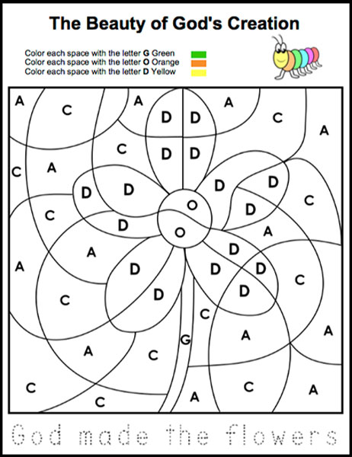
https://www.laymansbookstore.com/product/the-beauty-of-gods-creation-activity/
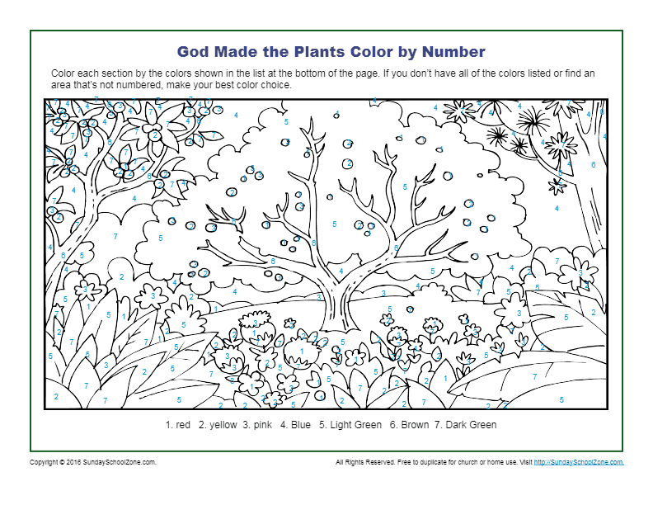
https://sundayschoolzone.com/activity/god-made-the-plants-color-by-number/
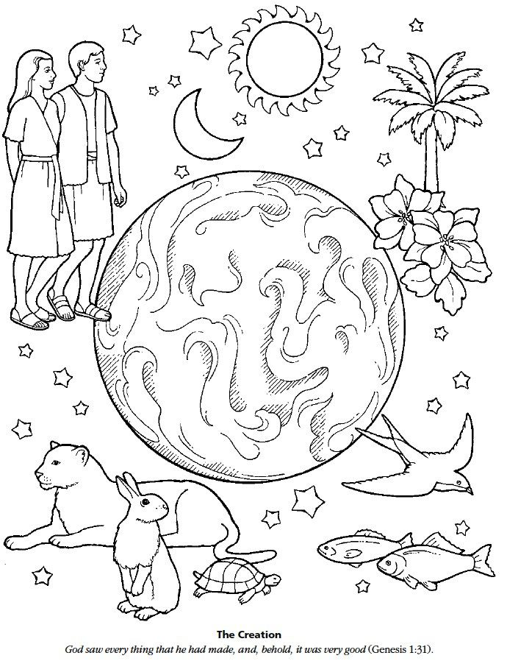
https://www.clipart.email/download/2687249.html
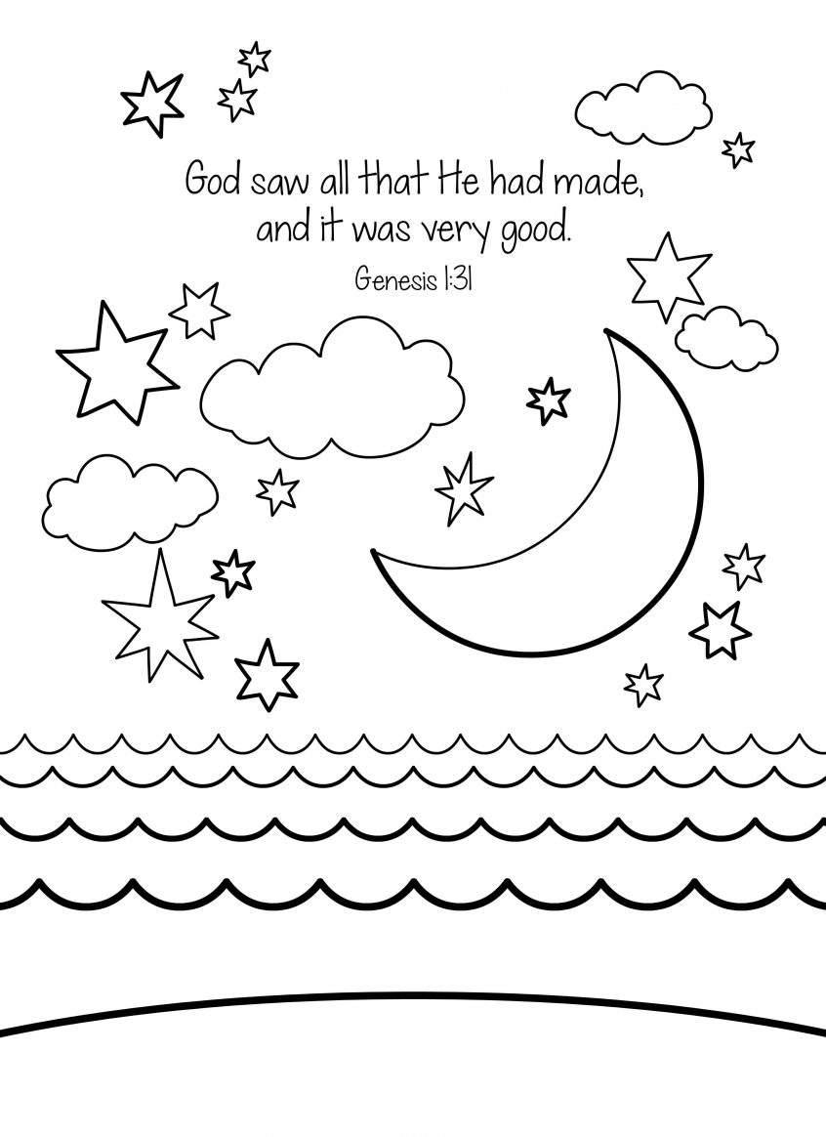
https://www.pinterest.co.uk/pin/337488565816923774/?nic_v1=1aO%2FXrUS1SMA22Nl8Ih1VZDfcc%2BwG1zDB1xY9kWj91CNbXQrjys0o31a%2BpdbGYGzE8
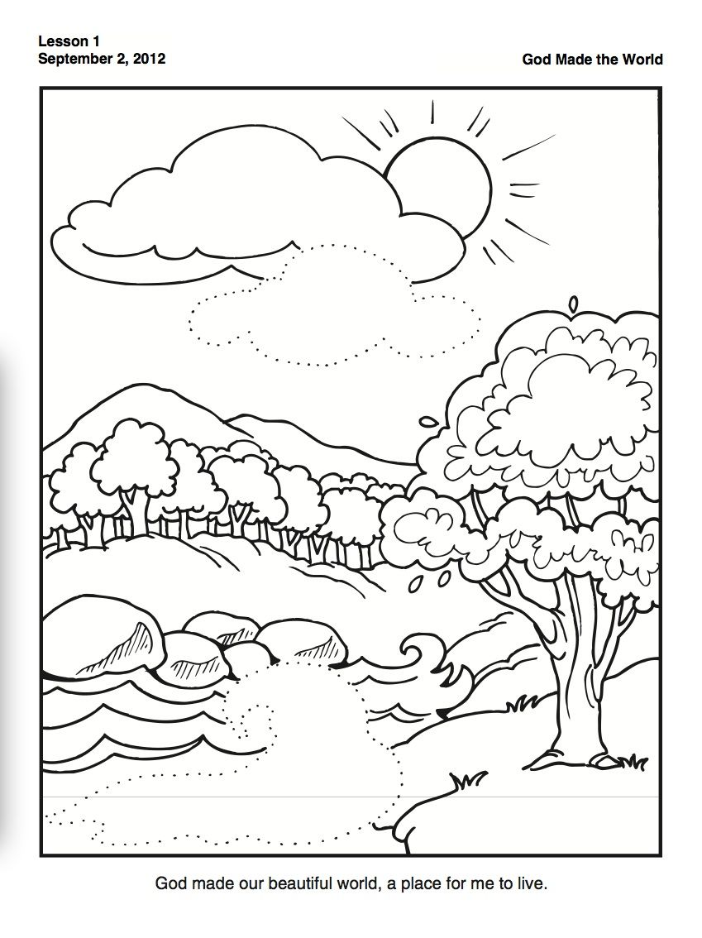
https://www.pinterest.co.uk/pin/781093129101569945/?nic_v1=1aM6RIFcfYXl3jVD5TV8bUCDm8DwCD59FM9aztUDfVCQS6A3sosvzHSttzmYCp8iW8
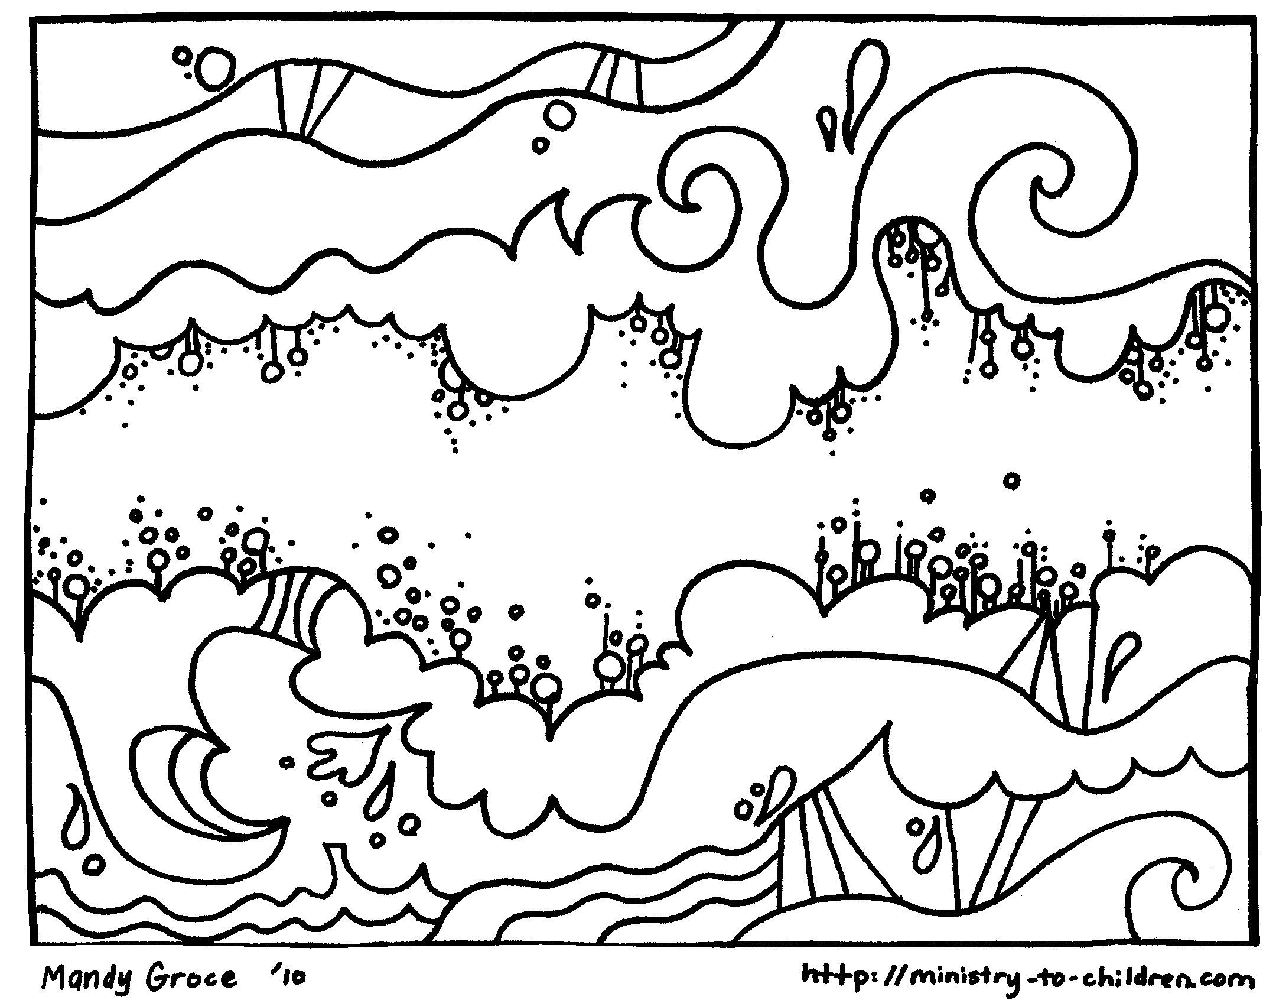
http://ministry-to-children.com/
http://www.nidaashow.com/creation-story-for-kids-coloring-pages/creation-coloring-pages-god-made-the-sky-welcome-to-grace-church-and-story-for-kids-free-new-neuhne-me-pages/
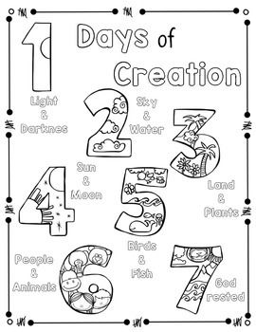
https://www.pinterest.co.uk/pin/65654107047728684/?nic_v1=1anrWJmYEg8PGWHW1Owo3Q01Ff%2Be1RSRng5Dx01G7mF6pfxGtPvblkovUsILpNqT9m

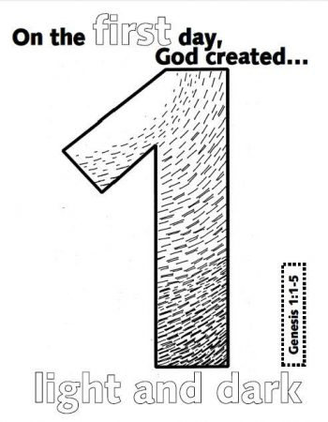
https://coloring.rocks/creation-coloring-pages/day-1-creation-coloring-pages/

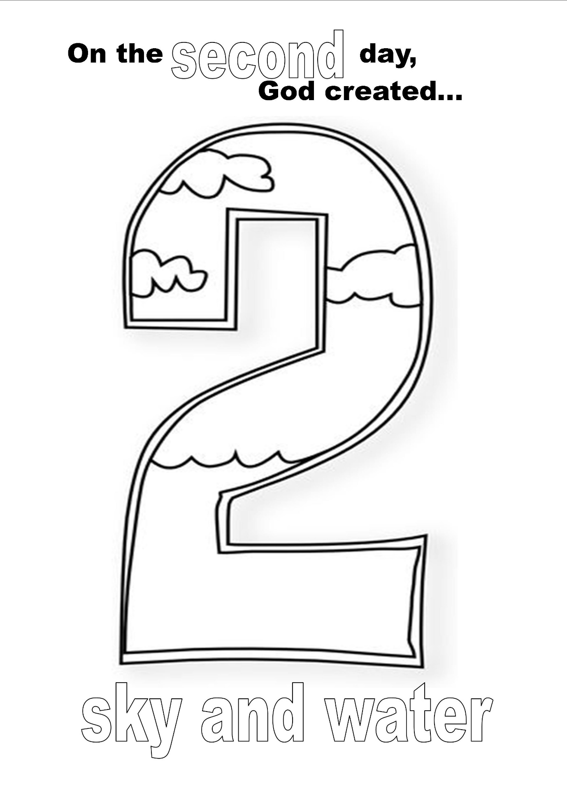
https://www.pinterest.co.uk/pin/985231146037325/?nic_v1=1ajsuD1ZCbzRUjKdj2LWKNbQFVvatCnJbvMrpArQRbqabDJK9XedlWuMIZMRo%2FNQNx
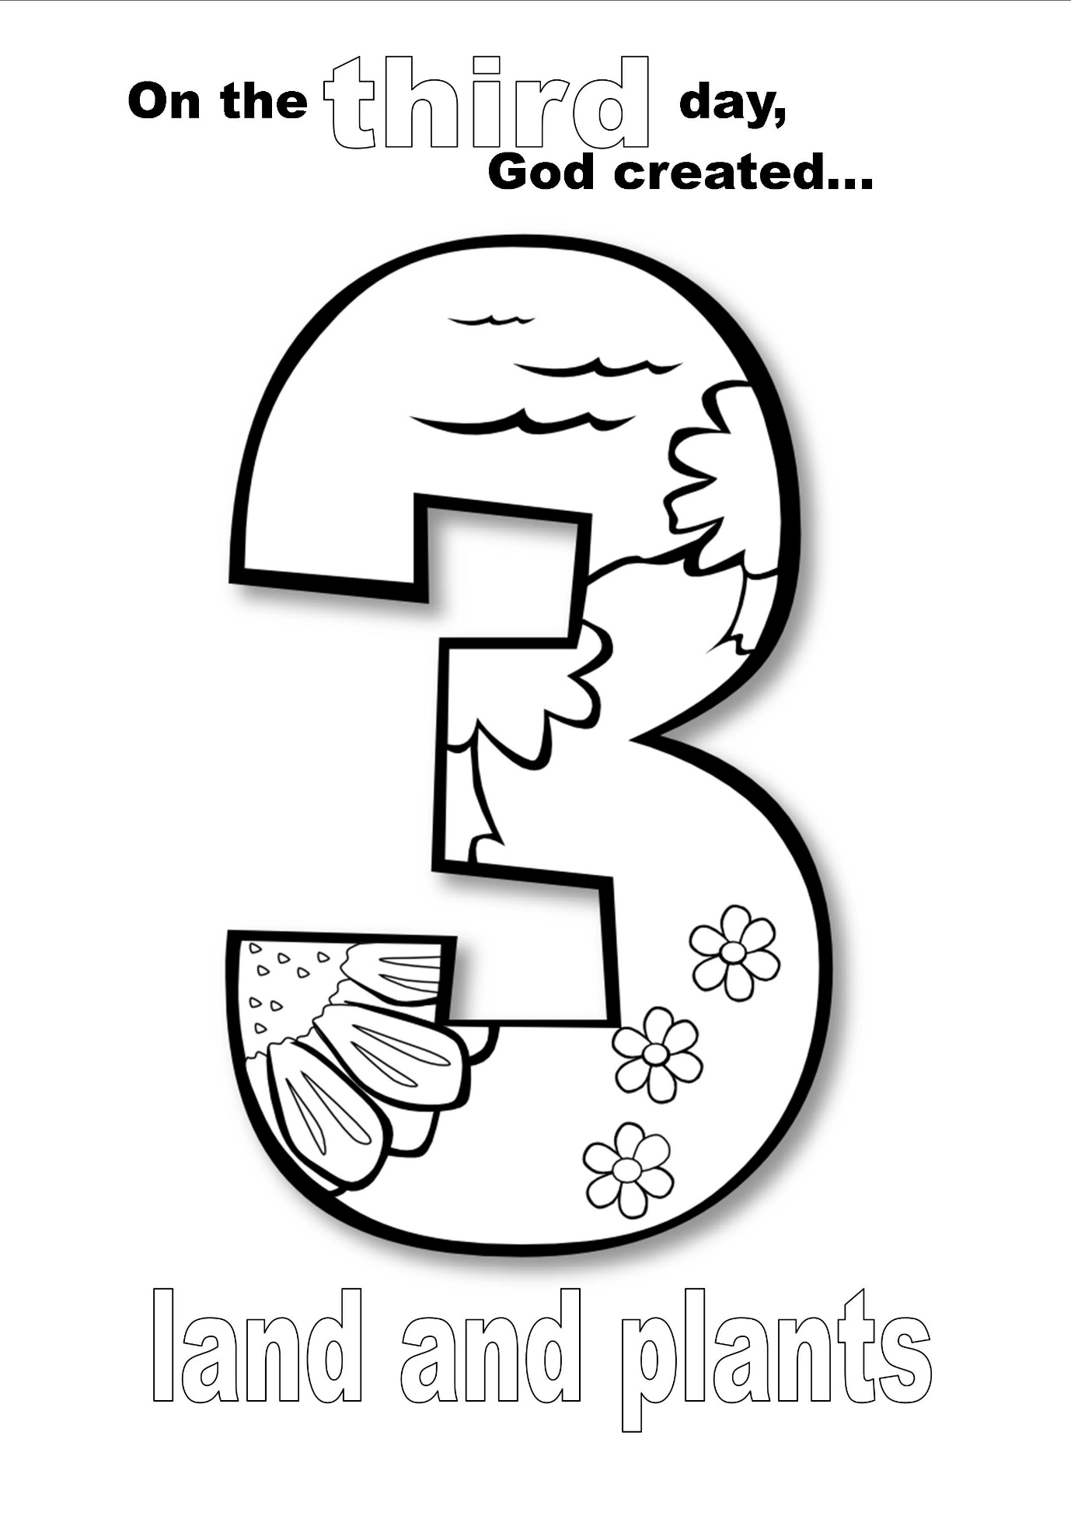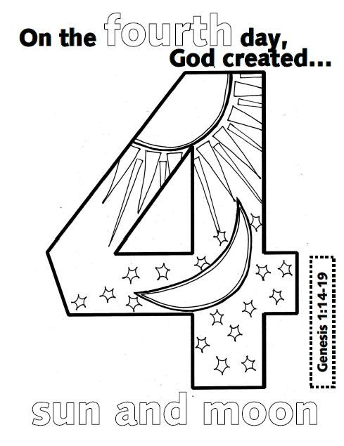
https://falcoaircraft.org/day-3-of-creation-coloring-pages/
https://www.pinterest.co.uk/pin/430375308118668989/?nic_v1=1aiZCvhHGuXwO7lGXS98pKgKy%2BX1wfwRj8MuYTSIVEUklAQugWnKPnVqaKaAvrdYRf

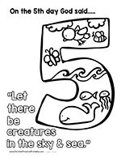
https://www.pinterest.co.uk/pin/497999671279822134/?d=t&mt=login
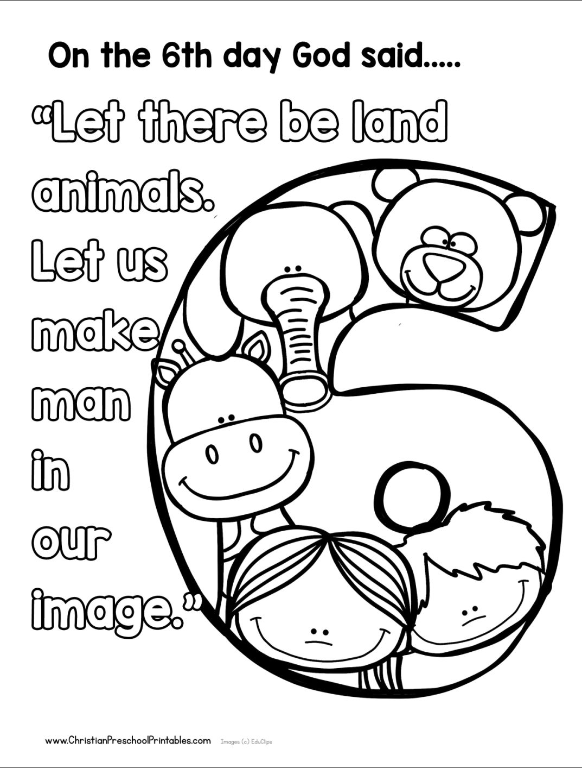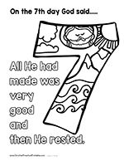
https://www.pinterest.co.uk/pin/497999671279822136/?nic_v1=1aea3Bg90V7k%2Bk4ubRS%2BnHxsXhb3ApMTcCWPsEu40o%2BUClggVdj2tKr%2BYTYniBOo5F
https://br.pinterest.com/pin/333477547397883258/?nic_v1=1aSe36Sh%2FdzIwIWUx6Bo%2FGC8qjZ%2B1Y%2FRmjKEIEVnpezeCkXQWzimMh2HVwjkk%2FB0wd

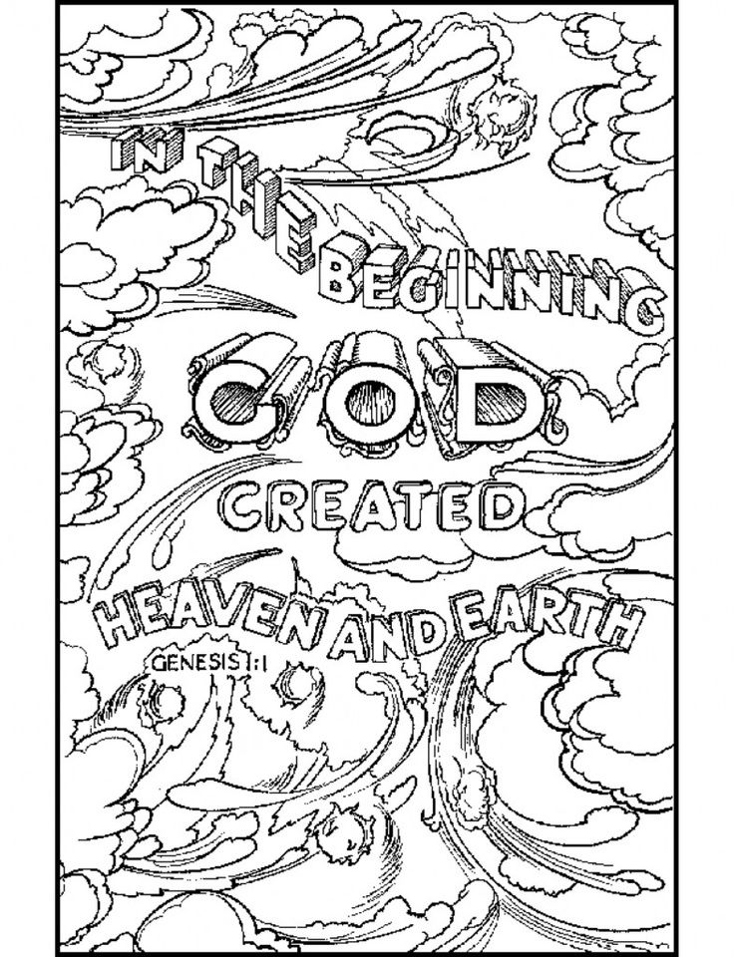
http://clipart-library.com/clipart/19-RiAy7RdrT.htm
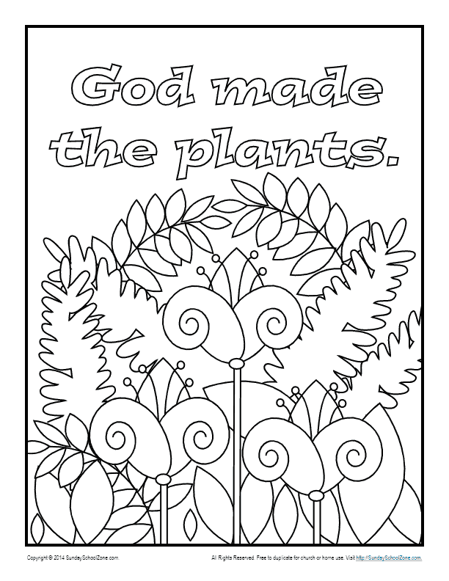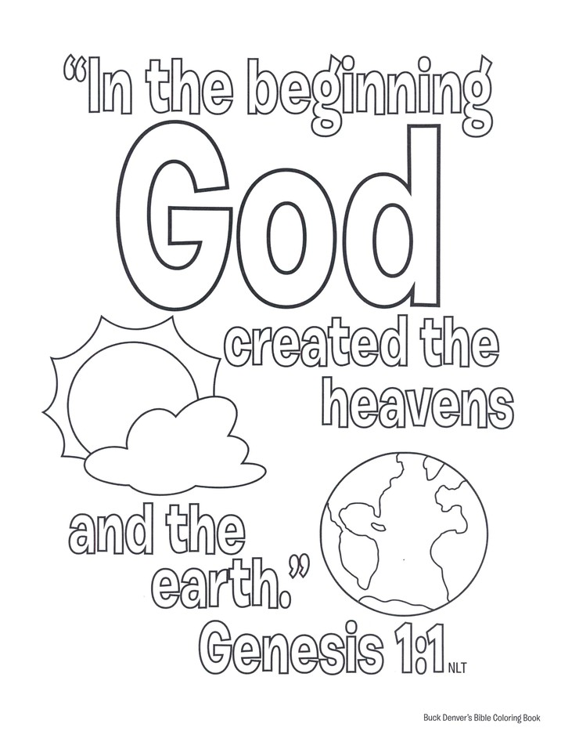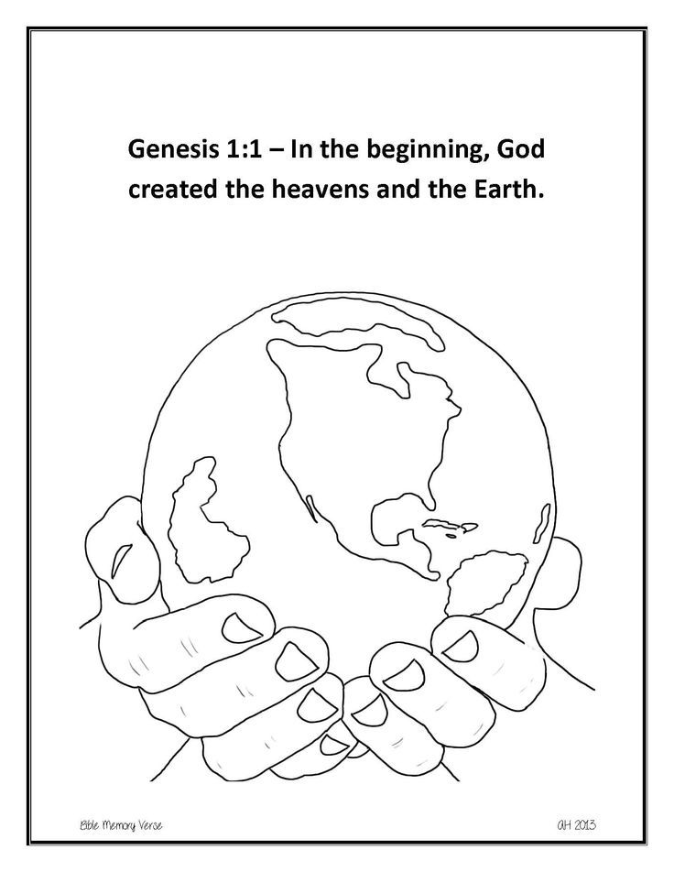
https://www.pinterest.co.uk/pin/514254851181247409/?nic_v1=1avTphh8bR7A0VQN9Sx%2Fl3eOLqmFS16npxnJK21RZ8rukeXHNx67yJ8VtJ5l934hpP
https://shop.gominno.com/products/buck-denvers-bible-coloring-book-old-new-testament-stories
http://clipart-library.com/in-the-beginning-god-created-coloring-pages.html
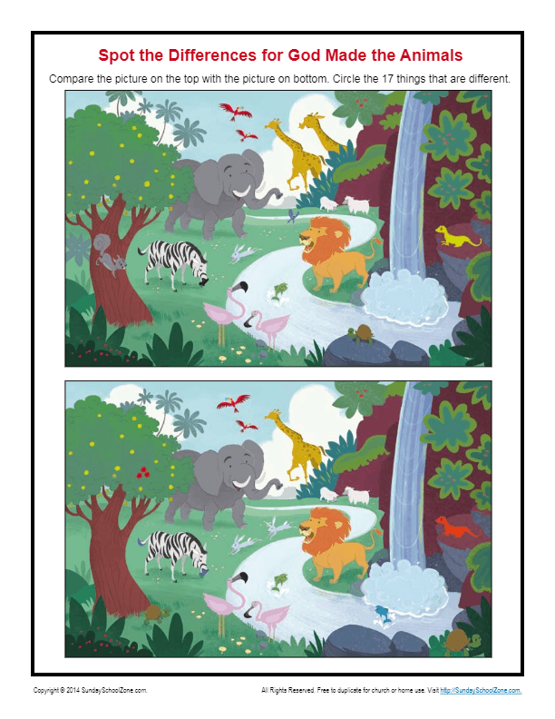
https://sundayschoolzone.com/activity/god-made-the-animals-spot-the-differences/
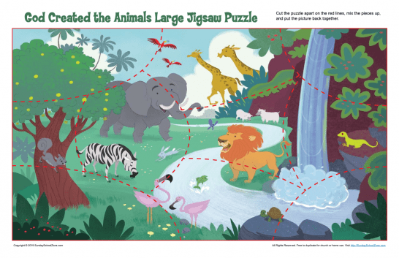
https://sundayschoolzone.com/activity/god-made-the-animals-jigsaw-puzzle-11x17/

