The Road to Emmaus
Luke 24: 13-35
Read the bible story and try some of the activities for 7-11s

Luke 24:13-35 Good News Translation (GNT)

The Walk to Emmaus
¹³ On that same day two of Jesus' followers were going to a village named Emmaus, about seven miles from Jerusalem, ¹⁴ and they were talking to each other about all the things that had happened. ¹⁵ As they talked and discussed, Jesus himself drew near and walked along with them; ¹⁶ they saw him, but somehow did not recognize him. ¹⁷ Jesus said to them, “What are you talking about to each other, as you walk along?”
They stood still, with sad faces. ¹⁸ One of them, named Cleopas, asked him, “Are you the only visitor in Jerusalem who doesn't know the things that have been happening there these last few days?”
¹⁹ “What things?” he asked.
“The things that happened to Jesus of Nazareth,” they answered. “This man was a prophet and was considered by God and by all the people to be powerful in everything he said and did. ²⁰ Our chief priests and rulers handed him over to be sentenced to death, and he was crucified. ²¹ And we had hoped that he would be the one who was going to set Israel free! Besides all that, this is now the third day since it happened. ²² Some of the women of our group surprised us; they went at dawn to the tomb, ²³ but could not find his body. They came back saying they had seen a vision of angels who told them that he is alive. ²⁴ Some of our group went to the tomb and found it exactly as the women had said, but they did not see him.”
²⁵ Then Jesus said to them, “How foolish you are, how slow you are to believe everything the prophets said! ²⁶ Was it not necessary for the Messiah to suffer these things and then to enter his glory?” ²⁷ And Jesus explained to them what was said about himself in all the Scriptures, beginning with the books of Moses and the writings of all the prophets.
²⁸ As they came near the village to which they were going, Jesus acted as if he were going farther; ²⁹ but they held him back, saying, “Stay with us; the day is almost over and it is getting dark.” So he went in to stay with them. ³⁰ He sat down to eat with them, took the bread, and said the blessing; then he broke the bread and gave it to them. ³¹ Then their eyes were opened and they recognized him, but he disappeared from their sight. ³² They said to each other, “Wasn't it like a fire burning in us when he talked to us on the road and explained the Scriptures to us?”
³³ They got up at once and went back to Jerusalem, where they found the eleven disciples gathered together with the others ³⁴ and saying, “The Lord is risen indeed! He has appeared to Simon!”
³⁵ The two then explained to them what had happened on the road, and how they had recognized the Lord when he broke the bread.

Imagine what the road to Emmaus looked like. Draw yourself as one of the people walking on the road to Emmaus. You can even cut out photographs of yourself and add them but please make sure you don’t cut up original photographs, ask someone to print some for you.

Read Matthew 28: 20
“Teach them to obey everything that I have told you. You can be sure that I will be with you always. I will continue with you until the end of the world.”
- Have you ever felt that Jesus is hidden from you?
- How can Jesus’ promise in this verse help you in the future?
Pray
Jesus, open my eyes to see how you are present with me each day.
Amen
Sharing
- Sit down together and share some biscuits and a drink
- Choose someone to say a simple grace for the food and drink you have and the chance to share this together, something like this:
  - Lord, bless this food that is set before us to feed us, and bless us also. Amen.
- While sharing a snack, begin talking about the story of the road to Emmaus and discuss the following:
  - If you were one of the people walking down the road, and you have been hearing about Jesus’ death and then the rumours about him being alive again, how would you feel?
  - When have you ever been very, very sad, and then realized that God is with you during this time?
  - How would you feel if you meet Jesus on the street? What would you say to him?
  - What do you wish he would say to you?
  - Think about Jesus breaking bread and giving it to the two friends. How do you think they recognized him in this action?
- To enhance this sharing time, have a piece of bread on a plate.
  - Invite the children to share with you in the breaking of the bread, and invite them to find in this action a sacred moment.
  - Pick up the bread, break it in half, then in pieces, and pass it around.
  - Ask: How does it feel to be part of this moment with Jesus?
Road to Emmaus activities

- You might need a magnifying glass or binoculars to read the following but when you can read it, write the verse in one of the glasses below and draw a picture of Jesus in the other.

Luke 24:31 New International Version (NIV)
- Then their eyes were opened and they recognized him, and he disappeared from their sight.

- Sit in the garden and look around you for a few minutes. If you have binoculars use them to look at your garden, it will look very different. Either draw or write down anything you haven’t seen before. It might have always been there but you never really looked for it or recognised it. This is like the two people walking with Jesus on the road to Emmaus, they didn’t recognise Jesus.
- Why not watch this Lego version of the story of the road to Emmaus on Youtube. https://www.youtube.com/watch?v=RLhSI4c-Blc
After watching the story, why not try and create your own lego version of the story. You could even try and record a short film of your own lego creation.
- Colour and decorate the bible story with images from the story. Remember to make it as colourful as possible. It will help you remember the story.

The Road to Emmaus
Luke 24 13-35

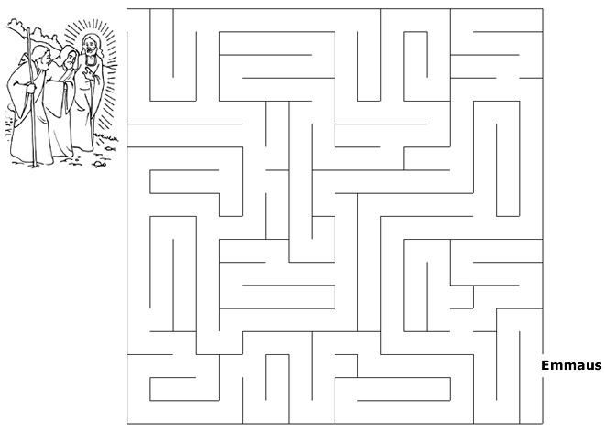
https://sermons4kids.com/emmaus_maze.htm
